Lab 2

Naoaki Takatsu

CECS 262

Task A

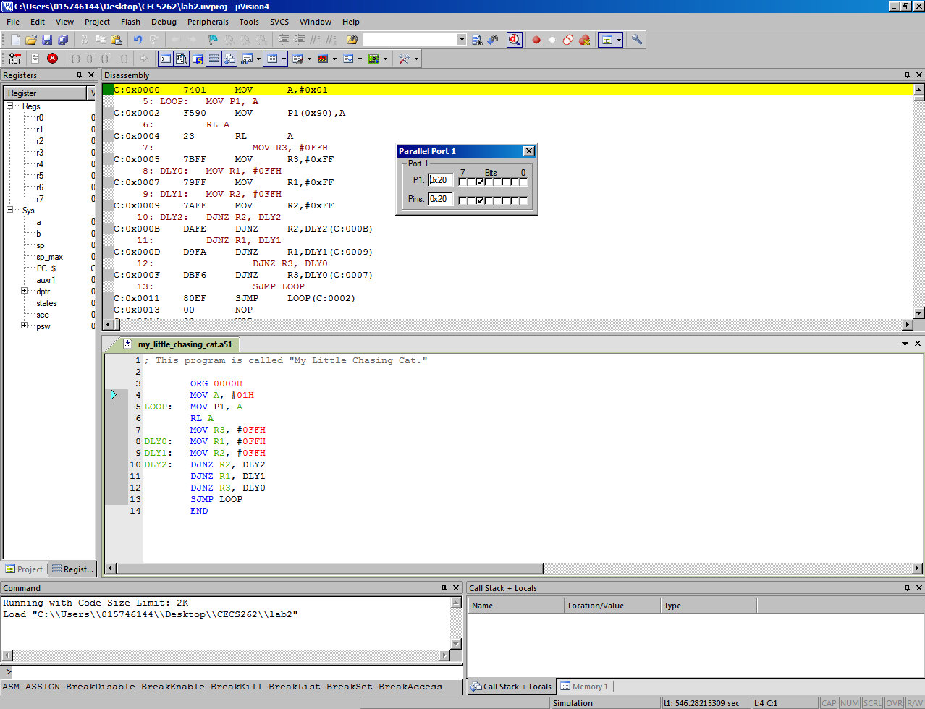

Task B

ORG 0000H

CY: 0

AC: 0

P: 0

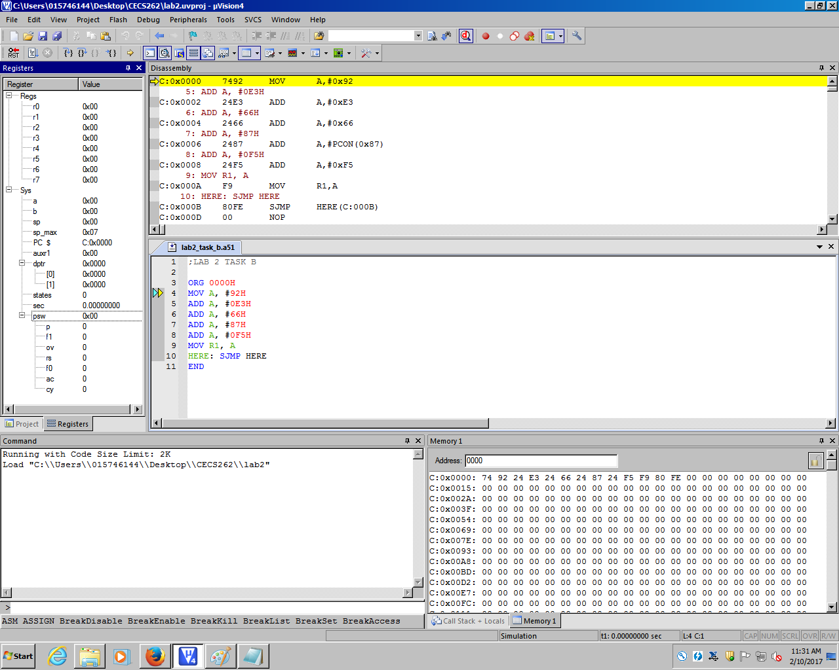

MOV A, #92H

A = 1001_0010

CY: 0

AC: 0

P: 1

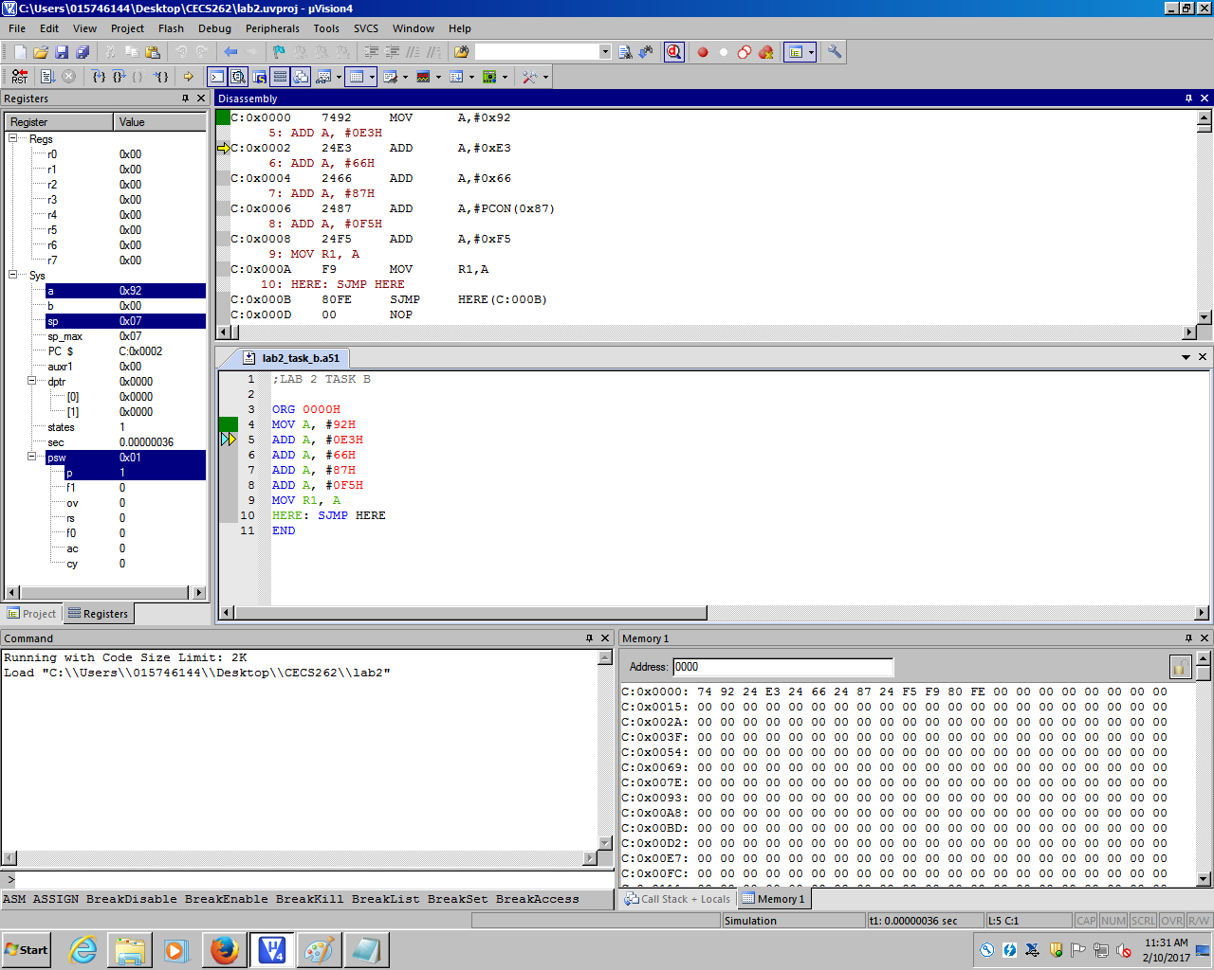

ADD A, #0E3H

A = 1001_0010 + 1110_0011 = 1_0111_0101

CY: 1

AC: 0

P: 1

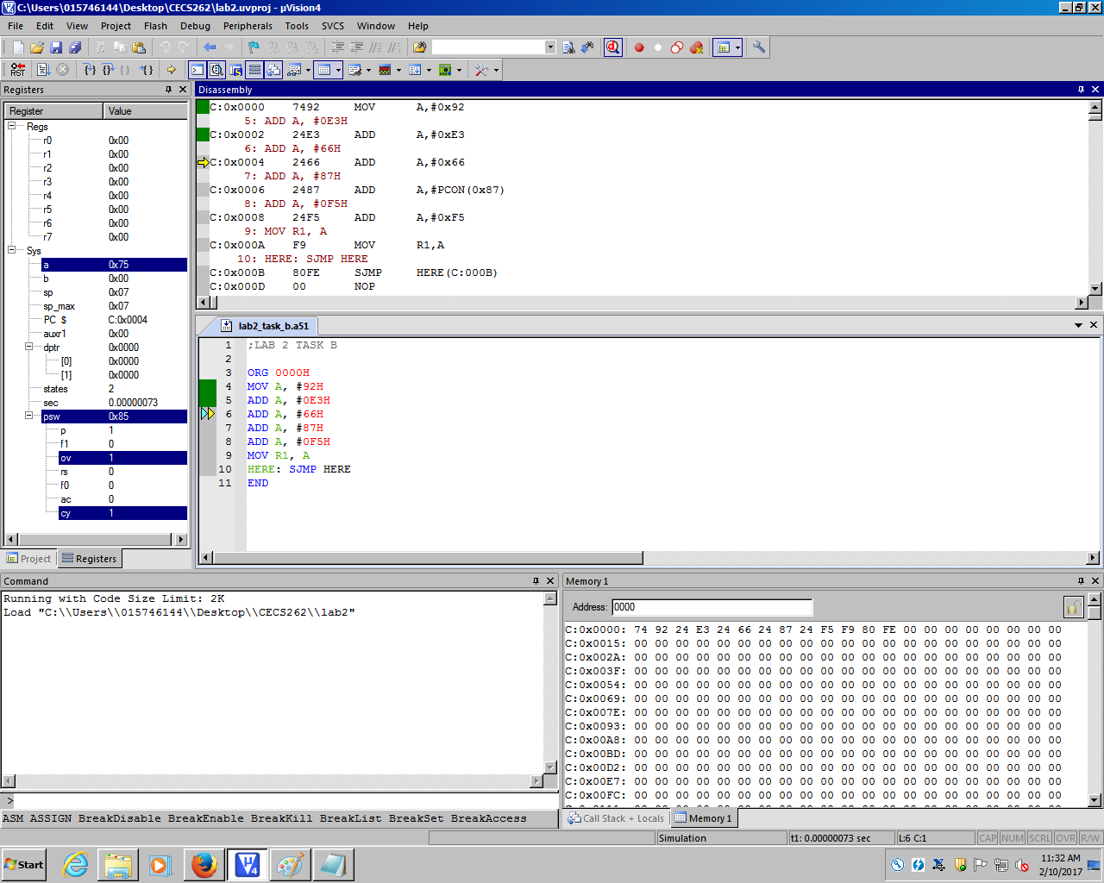

ADD A, #66H

A = 0111_0101 + 0110_0110 = 1101_1011

CY: 0

AC: 0

P: 0

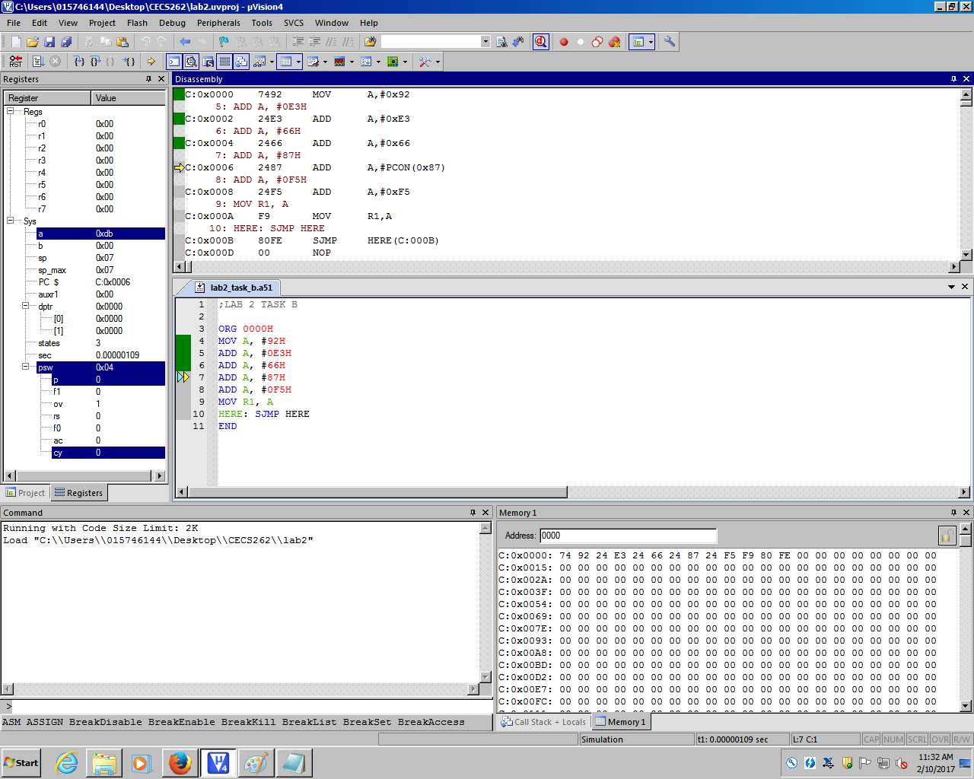

ADD A, #87H

A = 1101_1011 + 1000_0111 = 1_0110_0010

CY: 1

AC: 1

P: 1

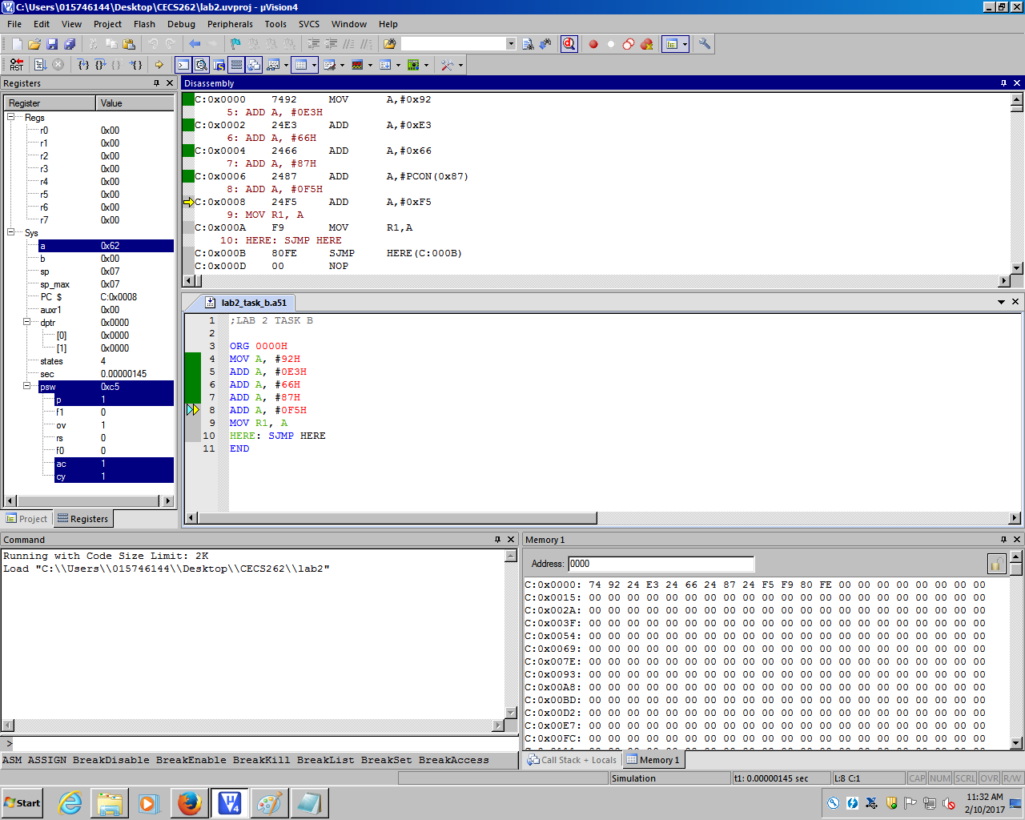

ADD A, #0F5H

A = 0110_0010 + 1111_0101 = 1_0101_0111

CY: 1

AC: 0

P: 1

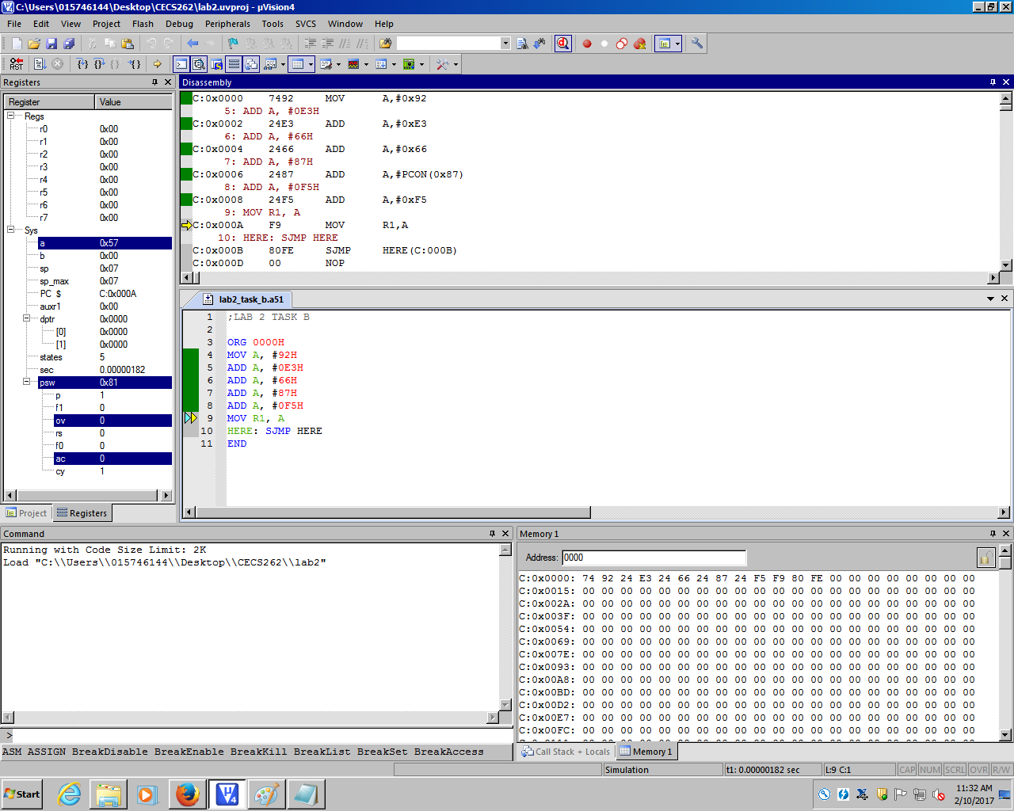

MOV R1, A

R1 = A = 1_0101_0111

CY: 1

AC: 0

P: 1

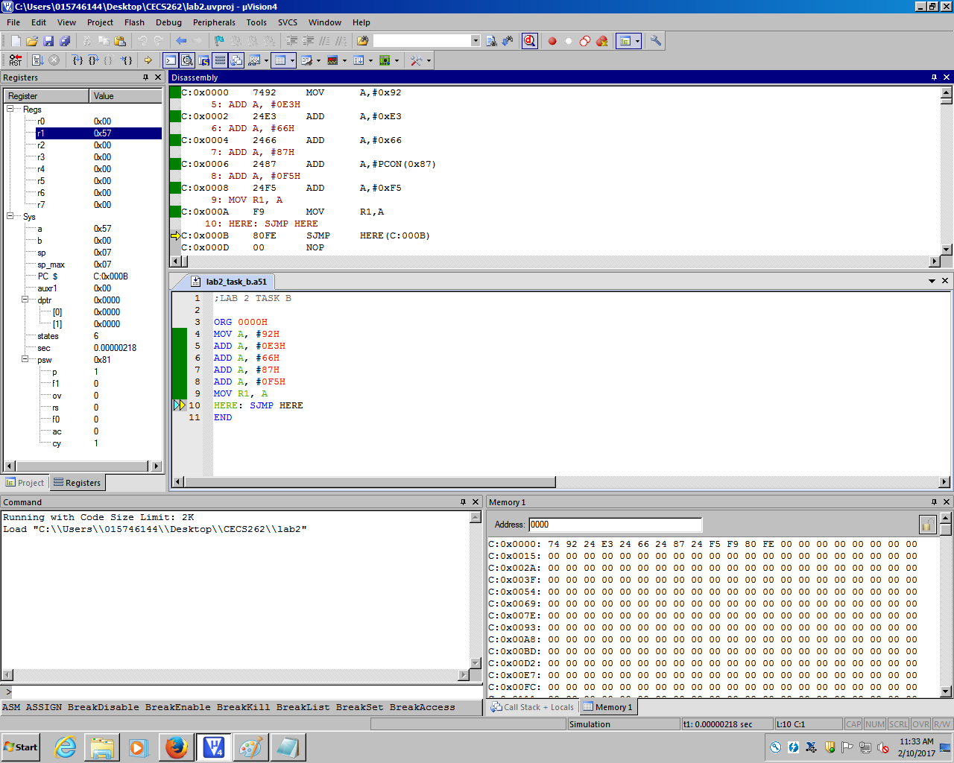

Task C

